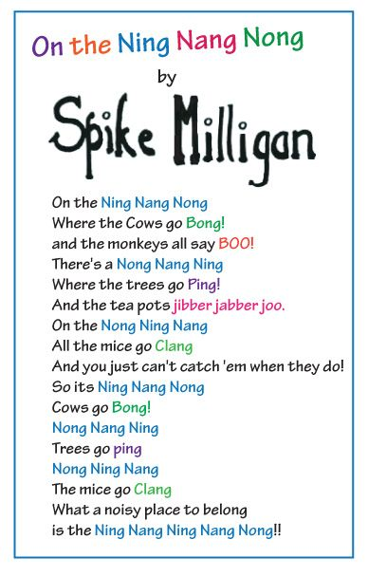

Activities:
(A)
Read this poem aloud to a parent or sibling (or perhaps to a grandparent via technology- I feel they would really enjoy it). Discuss some of the following questions (either you could answer, or ask your family member to answer.) *if you do not have anyone to read it to, just read it yourself
- Where is the Ning Nang Nong? Does such a place exist?
- Is this a serious poem? Give a reason for your answer.
- In the poem, what goes; bong? Ping? Clang? Jibber jabber joo?
- What instruments might be good at making some of these sounds do you think?

(B)
Milligan uses fun ‘alliteration’ in his poem. Alliteration is when the same letter or sound is used by several words in a row or close together. For example in riddles; ‘she sells sea-shells’, book titles; ‘demon dentist’ and song lyrics; ‘cause baby now we got bad blood’.
The title of this poem is an example of alliteration the ‘Ning Nang Nong’. Can you find another example of alliteration that Milligan uses in the poem?

Could you write some sentences using fun alliteration ideas for the following words: (you can write them into your h/w copy)
- dog 2. Dublin
- friend 4. footballer
- teacher 6. brother

(C)
Listen to the poet, Spike Milligan, reading aloud this poem using the following Youtube link: https://www.youtube.com/watch?v=0Wom1OzwzLw (or search Spike Milligan the Ning Nang Nong on youtube and click the one of the older man sitting in the arm chair).
Close your eyes and listen to him reading the poem. What do you imagine? Could you draw a picture of what you think this poem would look like? I would love if you could email me a copy of your picture.

