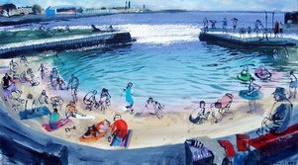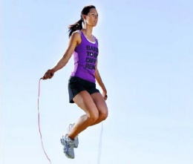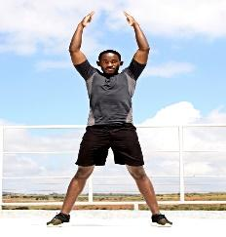

ARE YOU UP FOR THE CHALLENGE?
You are going to travel from Knocklyon to Dún Laoghaire for a virtual swim in the sea! It is 16 kms-ish. Can you make it by Friday 15th May for a virtual swim in the sea with everyone in your class? Here is how you can make your way. Each of the activities are worth steps and what do steps make - kilometres! Write in what you do each day and how far you have travelled. On Friday 15th May, perhaps you could take a funny photo of yourself ‘at the seaside’.
Remember that some step counters can give you steps when you shake your arm so be careful to only count real steps. Good Luck!
Around 1,500 steps = 1km
Around 700 skips with a skipping rope = 1km
You could count the steps from the back door to the end of the garden/around the garden. You could count how many stairs you have and run up and down as many times as you can.
Push ups, high knees, burpees and jumping jacks each count as a step.
 | ACTIVITIES | HOW FAR IN METERS? | HOW FAR IS LEFT?
Mon 4th
Tues 5th
Wed 6th
Thurs 7th
Fri 8th
SAT 9th
SUN 10th
Mon 11th
Tues 12th
Wed 13th
Thurs 14th
FRIDAY 15th of MAY

