Mapwork.
Use your atlas to help you fill in the gaps.
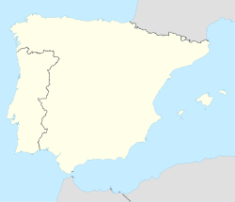
- The capital of Spain is ____________. Find its location and mark it on the map with a star.
- Spain is bordered by ____________ and ______________.
- Show the location of the Pyrenees Mountains on the map using the colour green.
- Label the countries Portugal, France, Morocco and Algeria on the map
- Label the Mediterranean Sea and the Bay of Biscay.
- Draw the River Ebro in the correct position.
- Name three cities in Spain. _____________, ____________ and ________________.
- Shade Portugal in red and Spain in yellow.
Spanish Festivals. 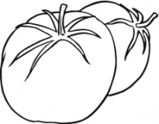
Spain is known for its many festivals.
We learned about The Valencia Tomato Fight Festival, also known as ‘__________’ held in a town called _______ in Valencia. Imagine you have travelled to see this festival. Draw a picture of what you can see.
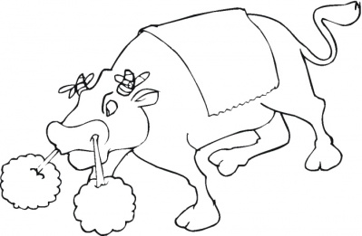
Spain is also known for its bull fighting and bull running. The most famous bull running festival takes place in a town called P________. This happens each J_____. Imagine you are standing on the streets of Pamplona watching the bull running. Draw a picture of what you might see.
Spanish Foods.
Read the following clues & unscramble the letters to name these Spanish foods.

A soup made of raw vegetables and served cold, usually with a tomato base, originating in the southern Spanish region of Andalusia.
______________________________ OAGHCZPA
A Spanish dish of rice, saffron, chicken, seafood, etc., cooked and served in a large shallow pan.
_______________________________ LAPELA
A sweet Spanish snack consisting of a strip of fried dough dusted with sugar or cinnamon
________________________________ HSOCURR
A spicy Spanish pork sausage.

________________________________ HROICOZ

A dish native to Spain, often served as a tapa in bars. It typically consists of white potatoes that have been cut into irregular shapes of about 2 centimetres, then fried in oil and served warm with a sauce such as a spicy tomato sauce or an aioli.

_______________________________TPASTAS VBARSA

