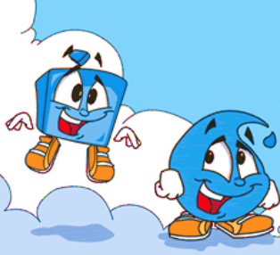
Solid or Liquid?
Test the substances listed below and decide if they are a solid or a liquid.
Tick the appropriate box and give reasons for your answer.
Why not add some of your own?
Substance | Solid | Liquid | Unsure | Reason
Sand
Cornflour
Oobleck
Whipped cream
Honey
Playdough
Whipped egg whites
Toothpaste

