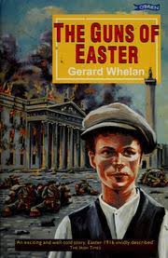

Here are some questions on chapters 7 to 10 of The Guns of Easter.

Most of them only require a word or two as an answer but the questions in ‘bold’ need a bit more thought and a longer, full-sentence answer.

Chapters 7 - 12

1 Why was Jimmy ‘miserable’ on p49?
2 What happened to his sister Sarah?
3 What was the old name for O Connell Street?
4 Why was it ‘drab and empty’ on a Monday morning?
5 Name the 2 men Jimmy recognised at the front of the group heading towards the GPO.

6 The 3rd man (whom Jimmy didn’t recognise) was Joseph Mary Plunkett? Describe him.

7 What was the name of the building where the union (ITGWU) had its headquarters?

8 Where was Padraig Pearse’s school?

9 Why was it unusual to see the Irish Volunteers and the Citizens Army together?

10 What did the local people think of the men marching with the two groups? (I.V. and I.C.A.)

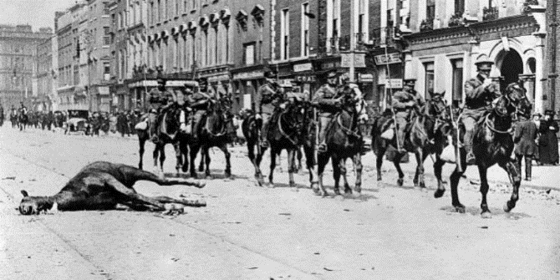
________________

11 What was the name of the old ‘revolutionary’ whom Jimmy recognised as the owner of a tobacconist shop?

12 Why did Uncle Mick want Jimmy’s mother to have his £4 savings?

13 What do you think happened to the £4? Why do you think this?

14 Explain why Jimmy’s mother allowed him to go out even though it was dangerous. (see p64)

_____________________________________________________________________________

15 Who were the Lancers?
16 What happened to them?
17 What did Jimmy do with the carbine (gun)?

18 On page 69, Jimmy was ‘shocked at the enormity of what he had done’. Explain this.

19 Countess Markiewicz appears on p70. Describe her.

20 Where did Aunt Ella live? What building for soldiers was nearby to her house?

________________________________________________________________________________________________

21 What was on the poster which the rebels put up? Give details. (see p76)

22 On p77, Jimmy decides not to suggest going to Ella’s to his mother. Explain his reasons for this.

23 Why did Tommy Doyle say ‘It’s better nor Christmas’ and ‘Ireland is free’.

24 What were the two drunken women fighting over?

25 What was Jimmy’s opinion of the people who were looting shops in Sackville Street?

________________________________________________________________________________________________

Vocabulary

These are words you will have seen in the chapters you read this week:

impressed frantically ransacked trampled

delirious peered dreading glared

inevitable revealed pleaded abandoned

Pick any six words and put each of them in a sentence.

You can change the form of the word; eg. glared / glaring / glares / glare

Try to make sure that your sentence makes it clear that you understand the meaning of the word.

Avoid using ‘I’ or people’s names in your sentences; pick an interesting subject eg. ‘ the experienced marathon runner’, ‘the cautious old man’ etc.

Try to include some of these in your sentences – powerful verbs, effective adjectives, adverbs, even metaphors and similes.

__________________________________________________________________________________________________

