1. Tarraing pictiúr: ‘Mo Theach’ agus cuir lipéidí ar na seomraí. (Draw a picture of your house and label the rooms).
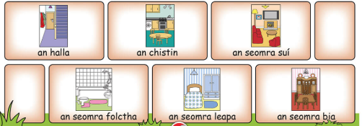

Mar Shampla: (For example)

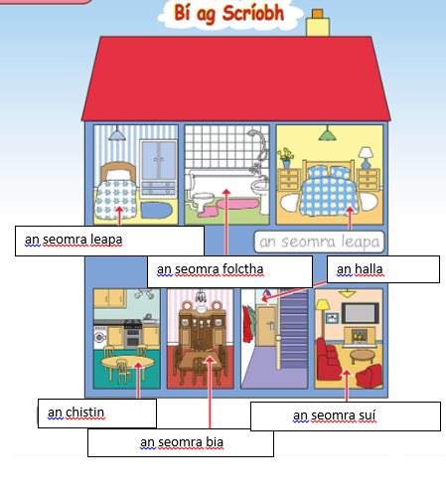

2. Líon na bearnaí agus scríobh na habairtí i do chóipleabhar. (Fill in the blanks and write the sentences into your copy).
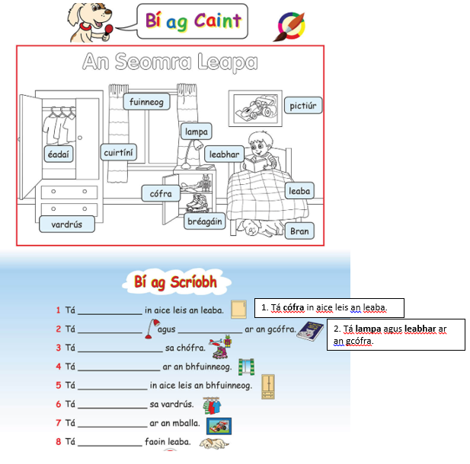
The answers to Q.1 and Q.2 have been completed.

3. Léigh an dán seo agus scríobh an dán i do chóipleabhar. (Read the poem and write it into your copy).
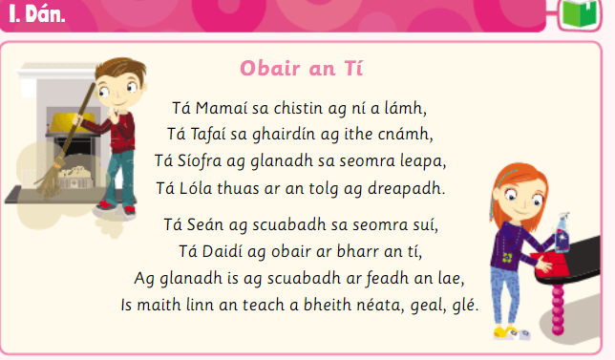

ag dreapadh (climbing) ar bharr (top of)
ar feadh an lae (during the day)

4. Déan an píosa seo sa chóipleabhar (Complete in your copy).
Match : Write the word with the correct picture.
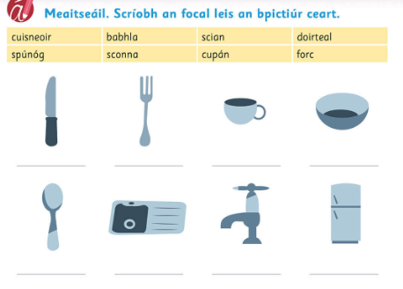
5. Glan (to clean)
Léigh agus scríobh i do chóipleabhar.
(Read and write this in your copy)
